Data wrangling:

Data is acquired from MightyScreen website (http://mightyscreen.sbgrid.org). Each row of data includes information like plate, well, platewell, readouts. There is an chemical database stored in mightyscreen that contain chemical’s properties, logp, molecular weight, structure and so on. The id I used to connect screening data to chemical database is the platewell because it is a unique id. All the scripts I wrote for data wrangling is in get_data.ipynb.

Plate Selector:

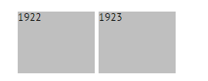

The current form of plate selector only has the plate number on it. And its interactive function hasn’t been finished yet. In the future, I want to include more information in this part, like the deviation of controls.

Channels:

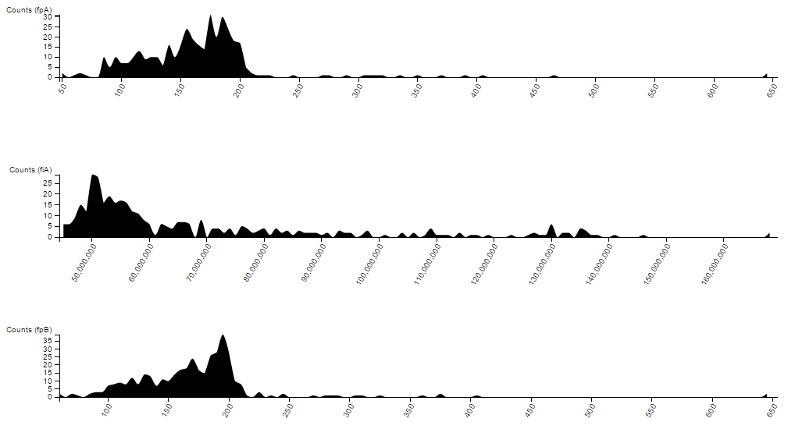

A channel is a type of readout that users choose to evaluate a chemical. In this milestone demo, I set three channels: first one is fluorescence polarization A (fpA); second one is total fluorescence (fiA); third one is fluorescence polarization B (fpB).

fpA and fpB are replicates. In the final form, channels will be changeable through dropdown boxes.

I presented each channel using an area distribution plot. Brushing feature is added but not fully implemented. The idea is to let users choose which fraction of data they want to focus on.

Plate Heatmap:

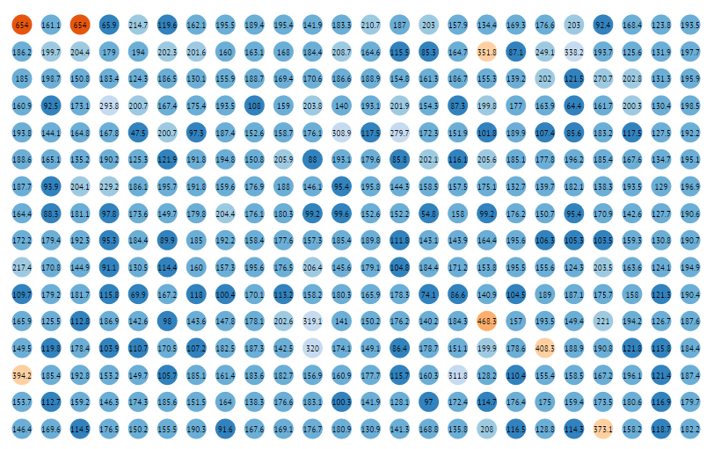

The assay plate is drawn on screen with each well colored according to its readout (channel 1). It is missing labels. The interactive feature of this part is not implemented. The idea is to click any well and see the chemical of this well.

Scatter plot.

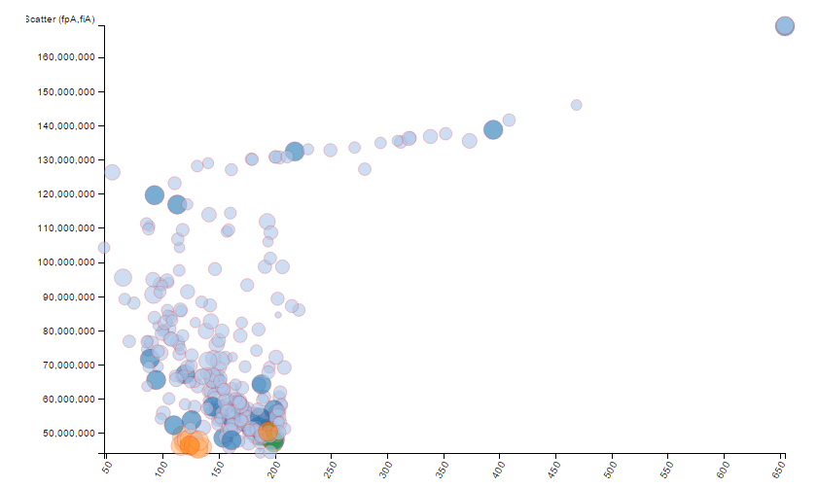

It is a scatterplot of channel 1 VS channel 2. Each dot is colored by its welltype. The size of a dot encodes its logp. The interactive feature is not implemented yet. But the idea is the same as plate heatmap.

Cloud Display:

This first step is to display scalable chemical structures. The svg code generated by openbabel is something looks like this:

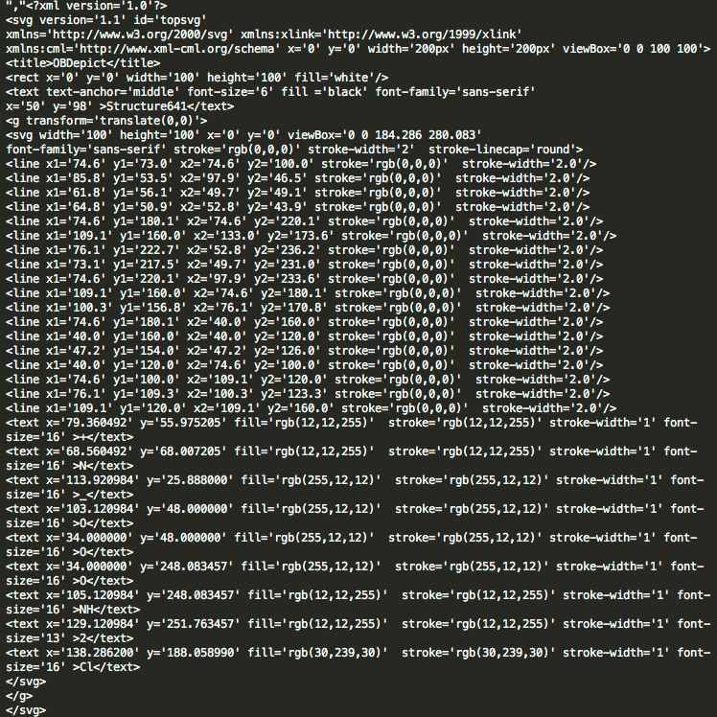

It uses viewbox which makes it easier to us to scale. I basically deleted all non-needed part and replace svg label to symbol:

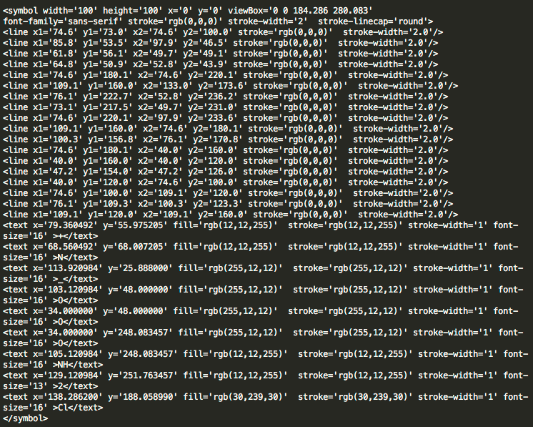

Now I can use <use> tag to draw the symbol at any scale:

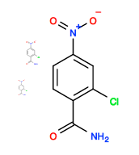

After feeding svgs to a force layout (with collision detection), it looks like this:

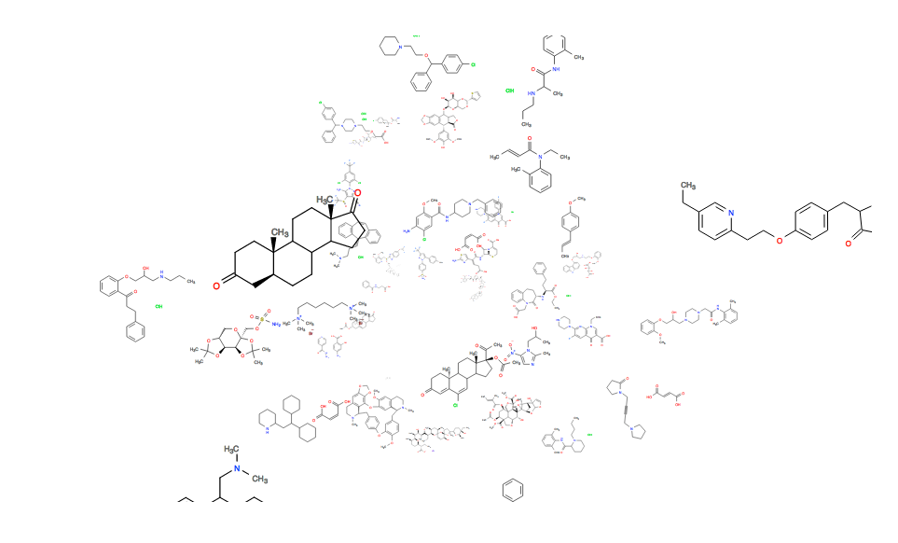

Current Issues:

1. It is hard to drag molecules. Possible solution is to draw a handle to each molecule.
2. Collision detection is kind of messy. Molecules overlap with each other.

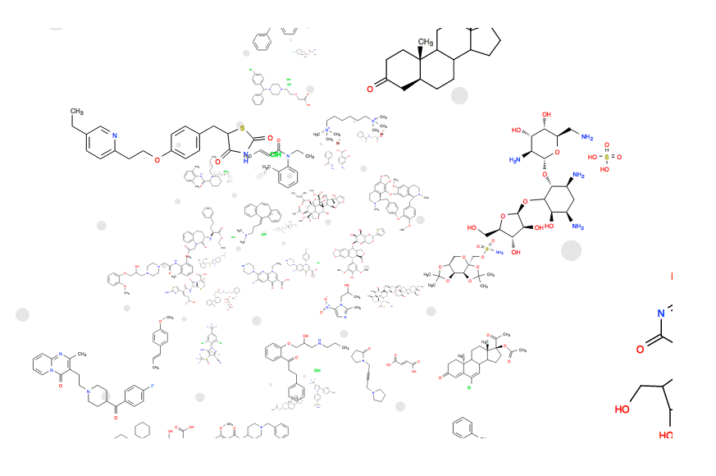

Now the handle has been added. Next step is probably encoding handle with the chemical properties: logp and molecular weight.